IS 340 Operating Systems

**HP04B: Installing CentOS on VirtualBox**

07/10/2019 Developed by Kevin Kuanting Chen

07/16/2019 Reviewed by Apiwat Chuaphan and Clark Ngo

06/17/2020 Reviewed by Kim Nguyen

Center for Information Assurance Education (CIAE) @City University of Seattle (CityU)

|  |  |
| --- | --- |
| C:\Users\chungsam\AppData\Local\Microsoft\Windows\INetCache\Content.MSO\C47DD46.tmp | C:\Users\chungsam\AppData\Local\Microsoft\Windows\INetCache\Content.MSO\846D80D0.tmp |

**Installing CentOS on VirtualBox**

1. Download CentOS
   1. Visit <https://www.centos.org/download/>
   2. Press the DVD ISO button.

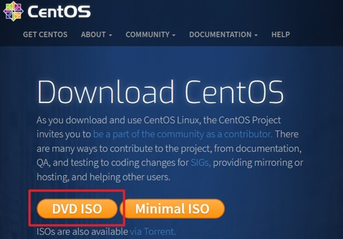

* 1. Download CentOS from one of the links on the mirror page.

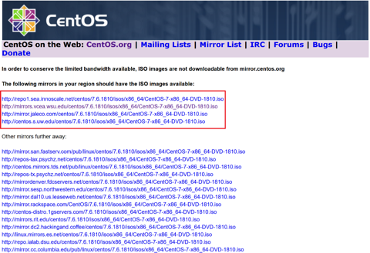

1. Create a Virtual Machine for CentOS.
   1. Open Oracle VM VirtualBox.
   2. Click New.

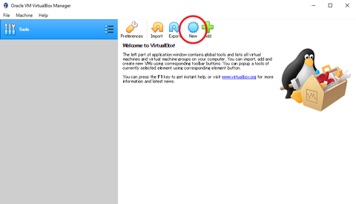

* 1. Fill in “CentOS7” as the name and select a folder for the virtual machine.   
     Select Linux type and Red Hat (64-bit) version and press Next.   
     Note that your CPU must support it.   
     For Intel CPU users, if the version drop-down list only shows 32-bit versions while you are running a 64-bit OS, you may have to enable **“Intel Virtualization Technology”** in your BIOS. If your CPU is AMD, you have to enable **“Secure Virtual Machine”.**

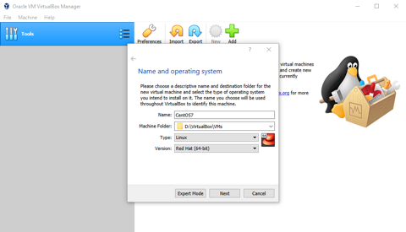

* 1. Allocate a memory size for the Virtual Machine. Set the memory size to 2048 MB. You can do more if your device has enough RAM.

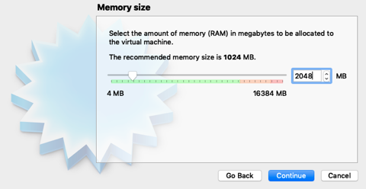

* 1. Make sure that Create a virtual hard disk now is selected. Press Create on the Hard disk page.

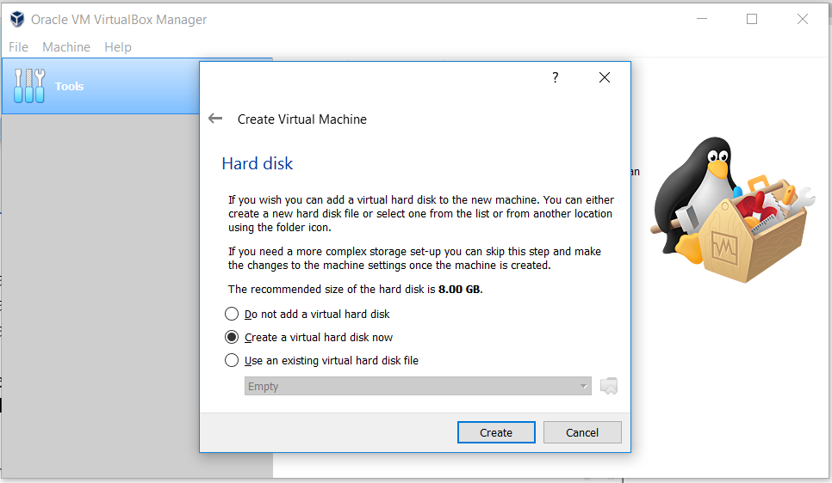

* 1. Make sure that VDI is selected. Press Next on the Hard disk file type page.

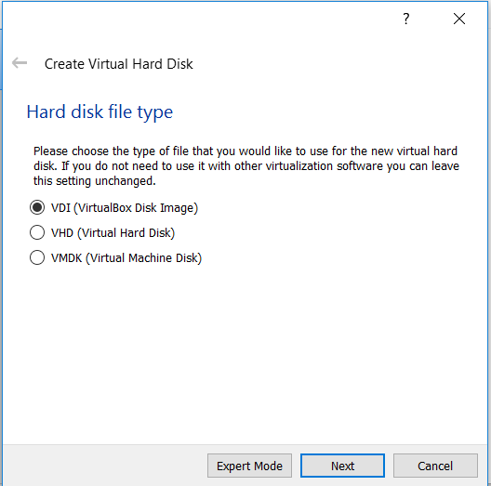

* 1. Make sure that Dynamically allocated is selected. Press Next on the Storage on physical hard disk page.

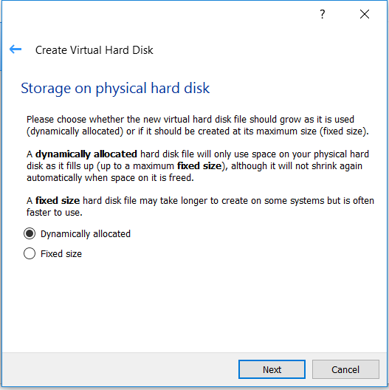

* 1. Check the file location and press Create on the File location and size page.

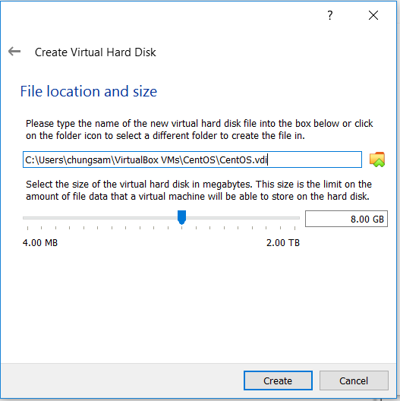

* 1. In Oracle VM VirtualBox Manager, click on CentOS7 on the left to highlight it. Select settings.

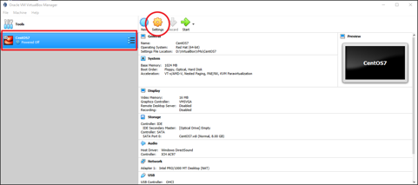

* 1. In the CentOS7 - Settings panel, go to Storage and highlight Empty in Storage Devices. Then, click on the disk icon in Attributes. Then, select Choose Virtual Optical Disk File.

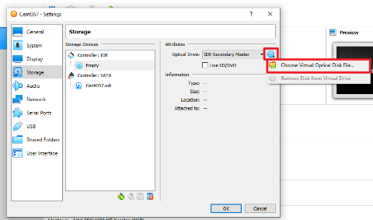

* 1. Open the CentOS ISO file you downloaded and press OK to leave the settings panel.

1. Install and configure CentOS.
   1. Press Start to start CentOS7.

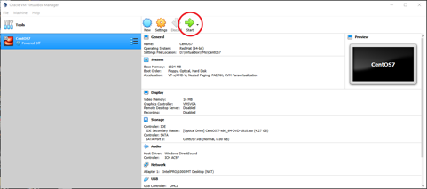

* 1. Use up and down arrows on your keyboard to highlight Install CentOS 7 and press enter.

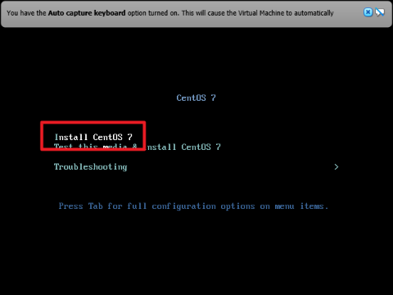

* 1. When installed, click inside the CentOS7 Windows. When you see the following message, read it first, select **Do not show this message again**, and press Capture.

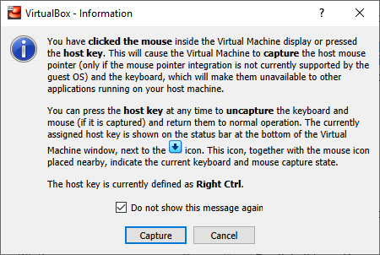

* 1. Press Continue on the language choosing page.

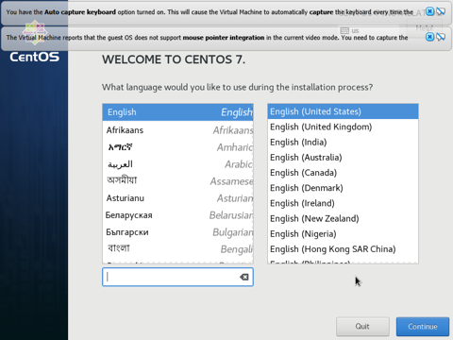

* 1. Under LOCALIZATION, press DATE & TIME to set the time zone to the West Coast.
  2. Under SYSTEM, press INSTALLATION DESTINATION and press DONE to accept the automatic partitioning setting. Then, press Begin Installation.

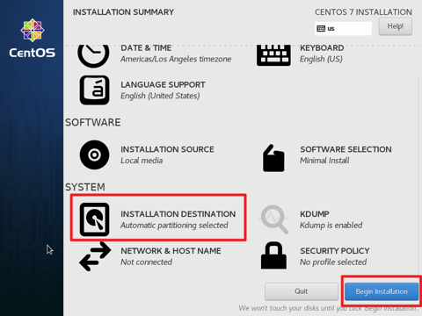

* 1. Under USER SETTINGS, press ROOT PASSWORD to set the root password.
  2. Under USER SETTINGS, press USER CREATION. Create a user for yourself, make sure the **“Make this user administrator”** box and the **“Require a password to use this account”** box are checked.

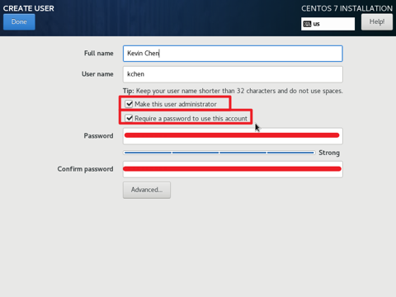

* 1. Press Finish configuration after you finish both user settings.
  2. When it is complete, press Reboot.

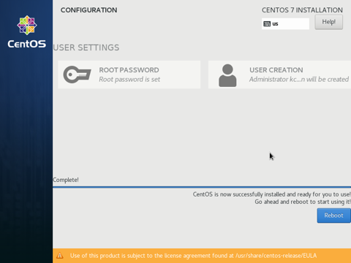

* 1. You can login with the user account you created.

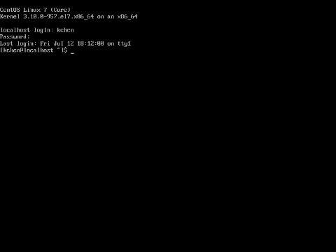

* 1. Exit your CentOS7  
     Click the red button on the top-left (Mac) or close the window (Windows).

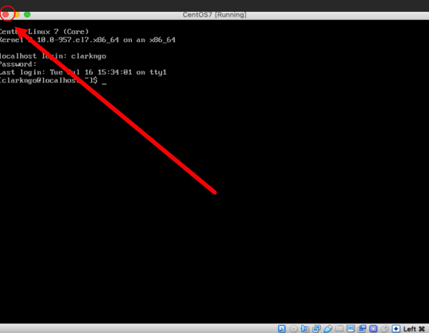

* 1. Choose Power off the machine and click OK.



